**ARYAMAN MISHRA**

**19BCE1027:**CSE3020 – Data Visualization Lab

**AIM:Carry out stated problems in Tableau and plot graphs and display results.**

**Pre-requisite:** Moderately familiar with basic concepts in **Tableau**, including data role, data connections and creating visual analytics in tableau.

**Use the Global Superstore dataset to do the visual analytics with respect to the following points. 1. Show the sum of sales for all the sub-categories and make distinction between categories by providing unique colour.**

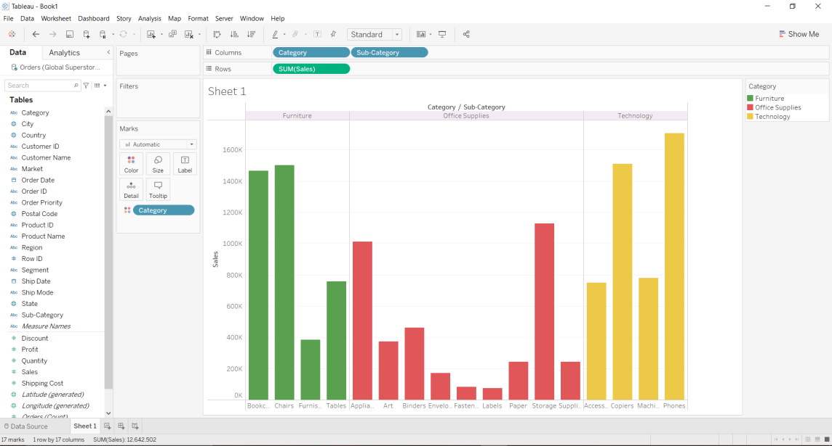

**2.Show the sum of Sales and Average Sales in India for all the sub-categories and make distinction between categories by providing unique colour. (you must use other colours, not as given in below figure**

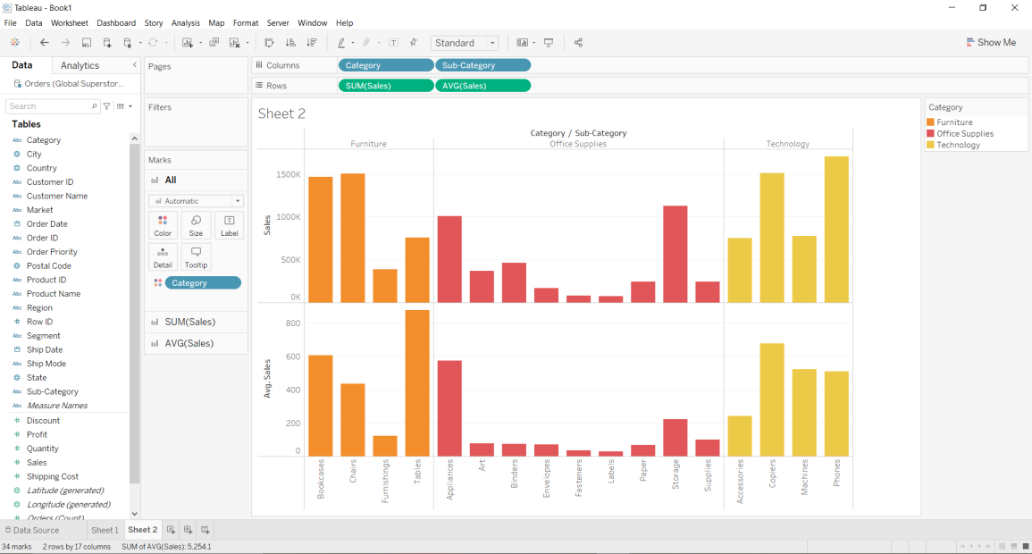

**3.Plot the sum of profit for each category and find sub category whose sum of profit is $- 64083?**

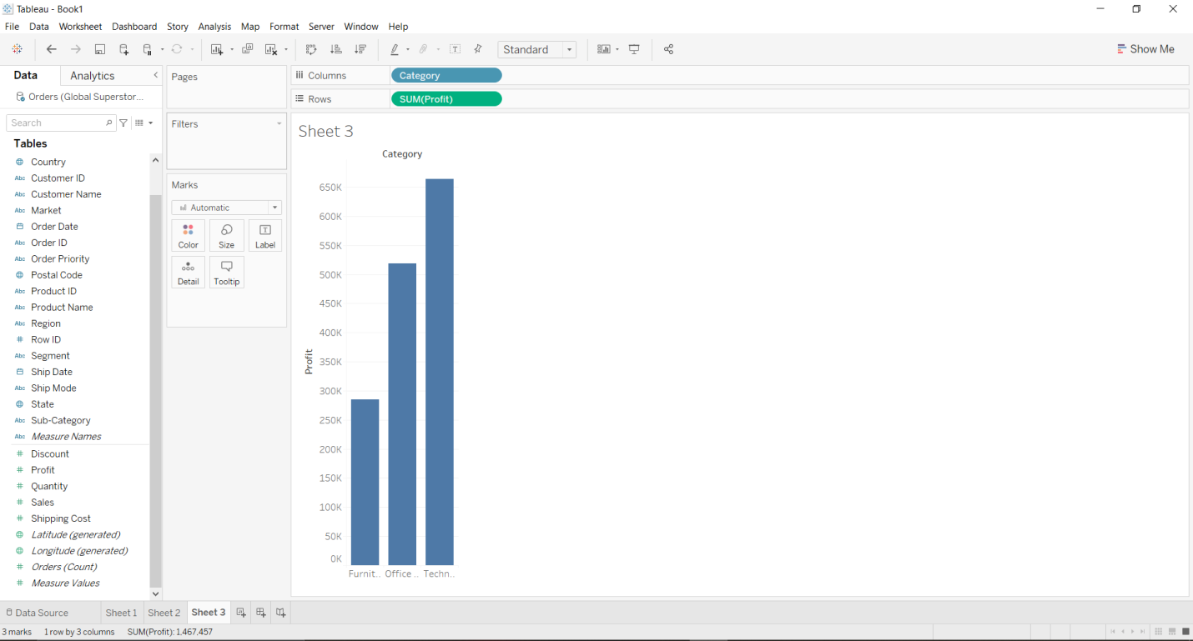

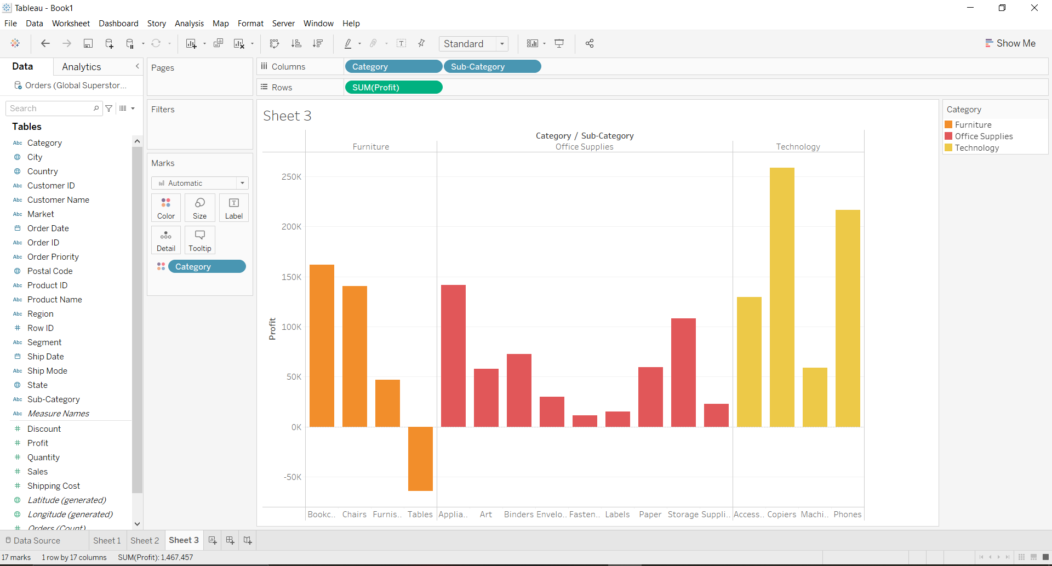

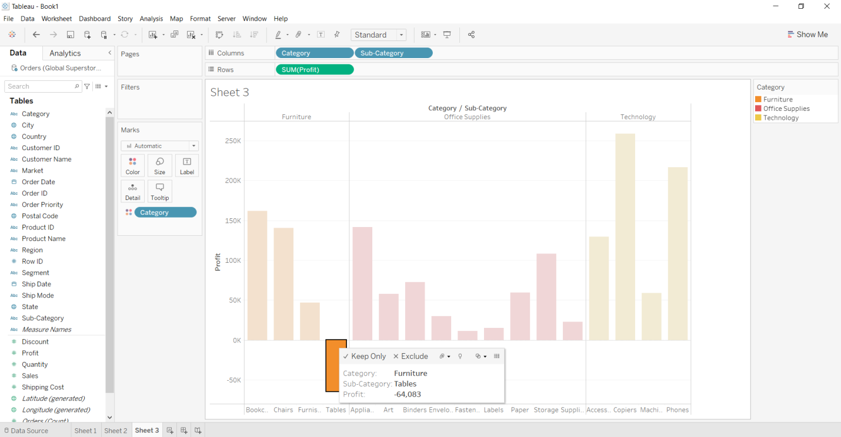

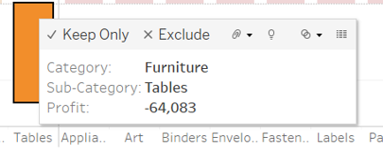

**4.Plot the customer with highest overall profit and find the customer’s name and his/her profit ratio.**

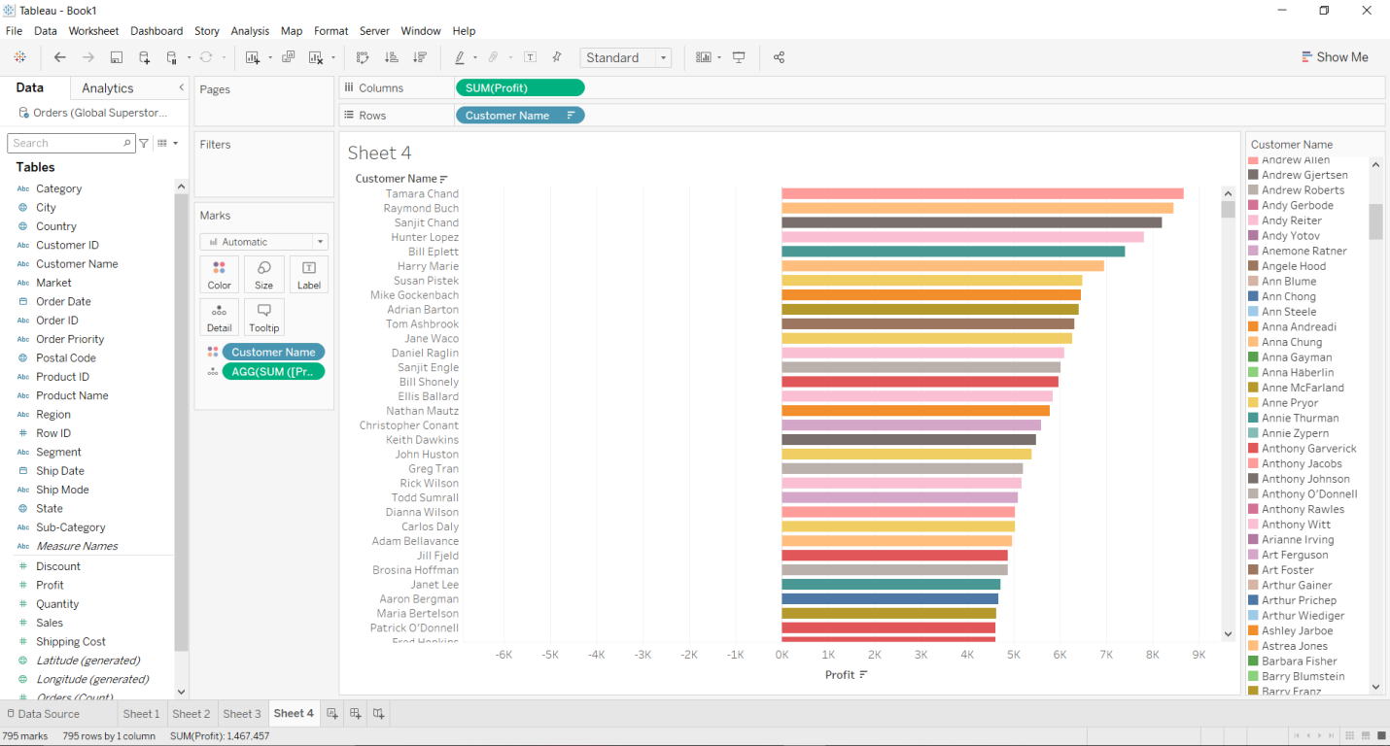

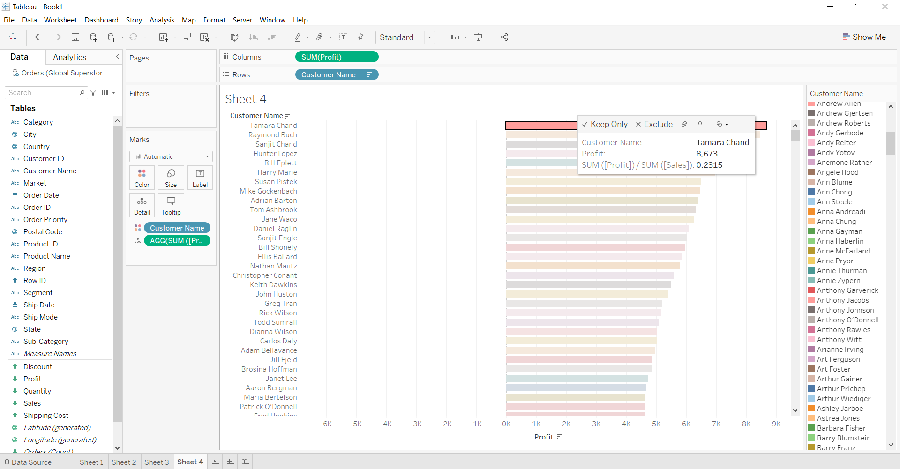 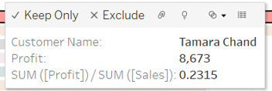

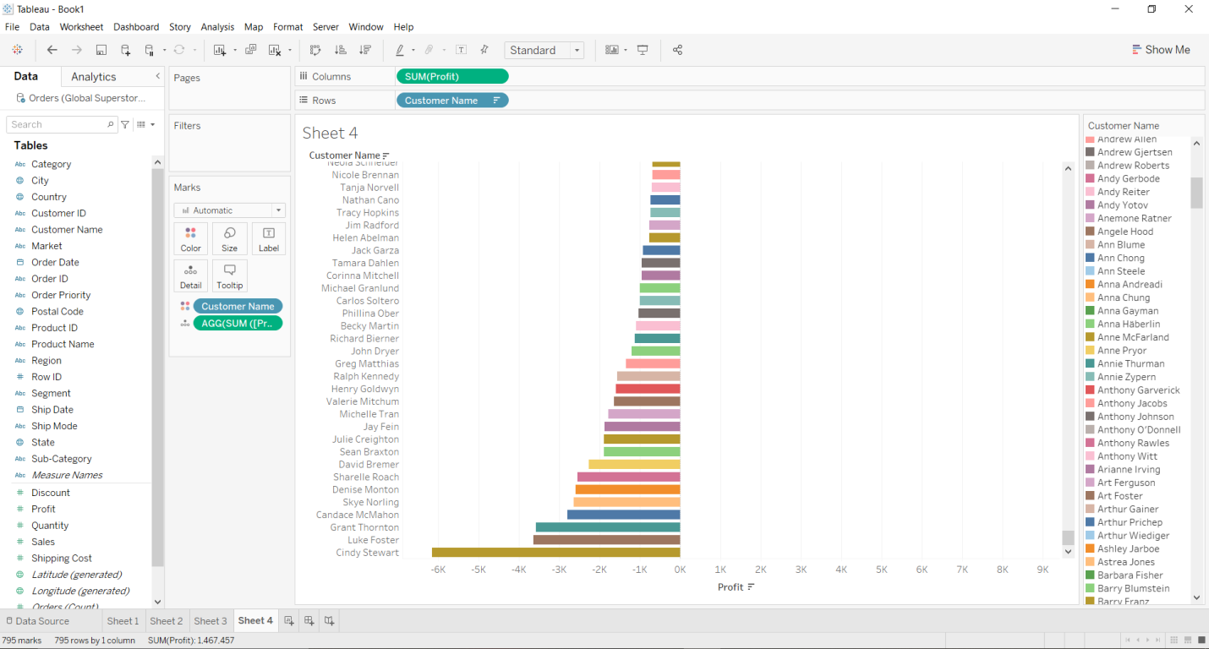

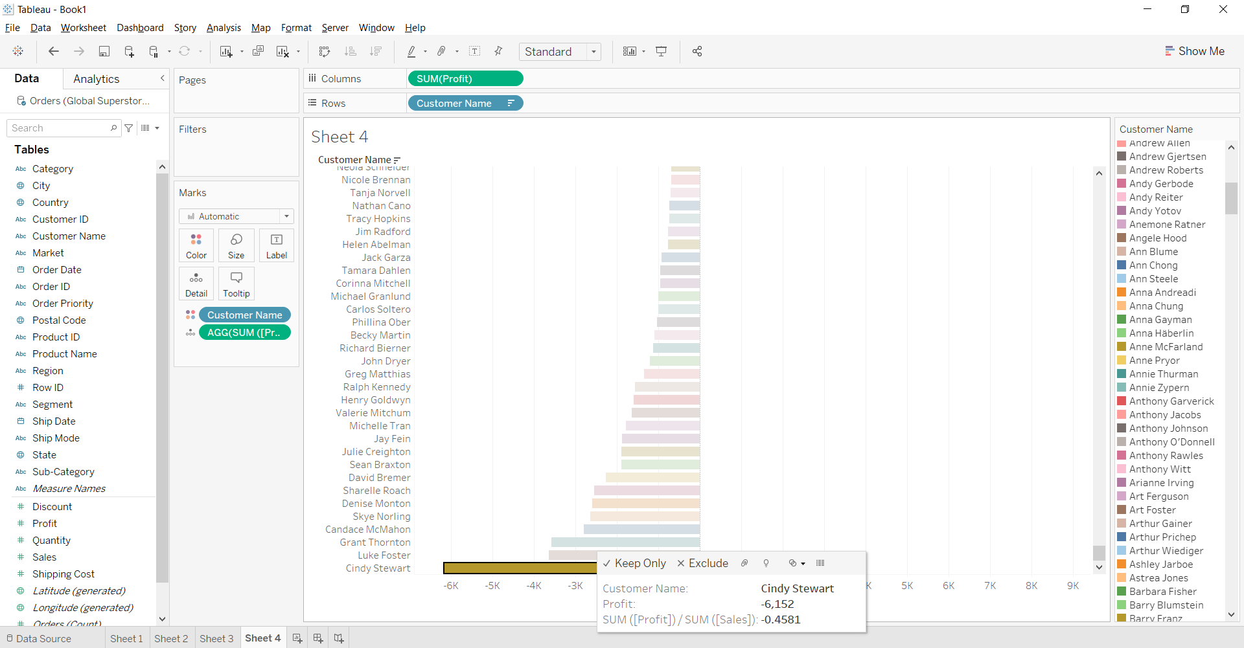 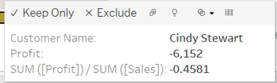

**5. Plot the sum of profit for each category on various shipping date along with four quarters. Find the sum of profit for furniture category in the year 2013 during fourth quarter.**

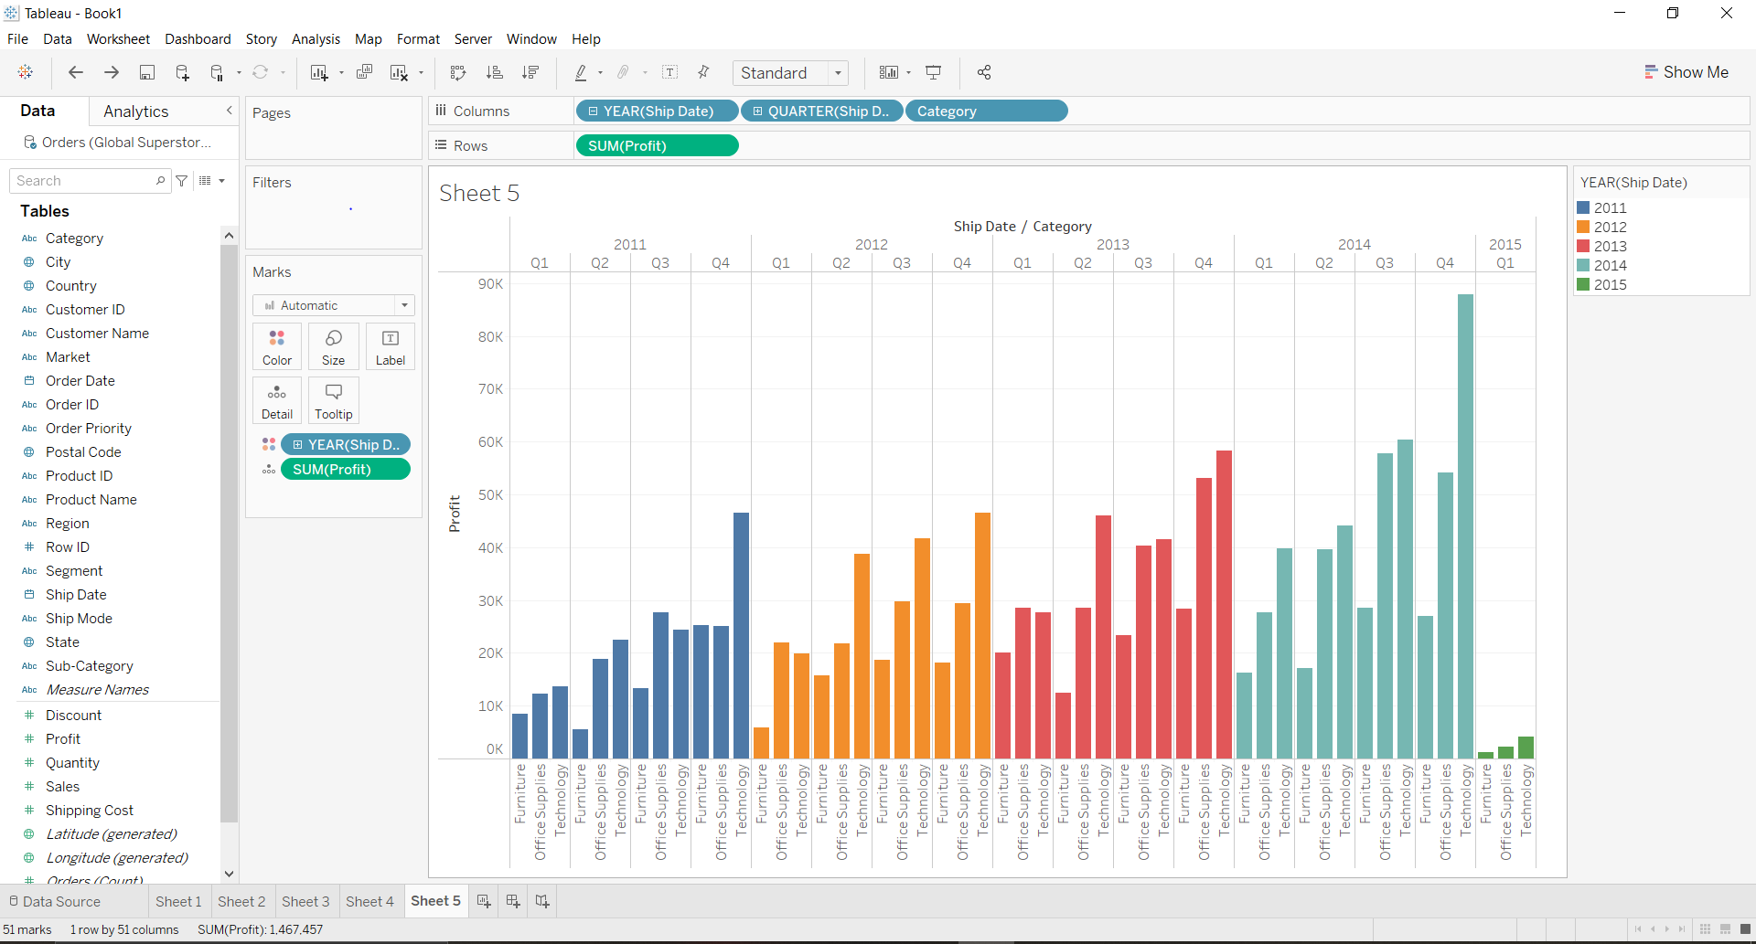

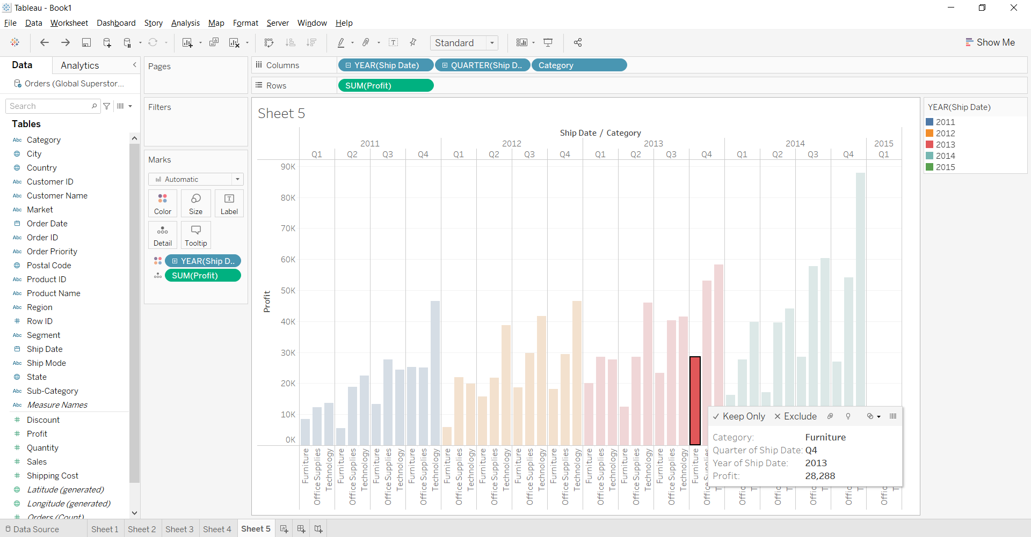

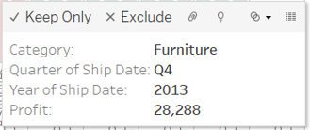

**CONCLUSION:ABOVE PROBLEMS HAVE BEEN PLOTTED IN TABLEAU AND RESULTS HAVE BEEN MARKED.**